Hitchin Footpath Problems – March 2017 Update
Report Structure
Overview
Part A Summary of current issues.
Part B Update on issues reported previously.
Part C Issues that we did not prioritise in the last report.
Overview
We have investigated over 50 of Hitchin’s paths during February and early March. We have found no real issues to do with surface, vegetation or structures, and some significant improvements following the last report. Although there are no new issues to report, there have been some changes in the status, or I have modified my view of some ongoing problems– see part B.
As previously, the following longer term issues remain and are not solely the preserve of HCC. I will continue to record these, as the Forum does attempt to highlight them with NHDC in a number of ways.
- Paths that deliver the walker to a road with no safe onward pedestrian route or crossing (obvious examples are the northern end of FP27 at the B655 Hexton Road, FP29 at its junction with the A505 and FP89 at the Stotfold Road).
- Unsightly sites bordering paths which attract litter and fly-tipping which spills over onto the path – the enclosure of the electricity sub-station at the junction of Maxwell’s Path (FP18) and Union path (FP20) is an example here. The same applies to FP 80, the verges of which have recently been cleared of vegetation to reveal fly-tipping into the hedge beyond. I have complained to NHDC about this, and at the time of writing, it has been passed to their Enforcement Team.
- The lack of any explicit strategy on walking, mention of the Rights of Way Improvement Plan or liaison with HCC in NHDC’s Submission Local Plan (HF has raised this in its comments on Policy HC1 in Section 10 of Hitchin Town Action Group’s Response to NHDC Submission Local Plan¹, which will be passed to the Inspector).
Part A Summary of highest priority new and continuing issues

Description. Report section with further details appears in brackets. | Footpath or bridleway no. | New or continuing
Prevent access to trail bikers on Oughtonhead Lane – a long term problem, but especially now since surfaces are much improved. Continue to monitor similar abuse on RBW94 (B5, B6) | RBW4 and RBW94 | C

Part B Previously reported issues
1.HOOP between Gypsy Lane (FP94) and Wymondley Road / St Michaels Road roundabout
Both verges have been cut and are passable. Visibility to the west of BW6 is restored. The signpost now points in the right direction.
2. Footpath 10
The patch over the pothole continues to hold-up well.
3. Footpath 26
As I commented previously, the new drain could easily be blocked in future by detritus and needs to be monitored. Again, I visited after a period of dry weather. By comparison with its state in the summer of 2016, the drain seems to be now nearly blocked, but it is unclear whether this results in flooding after rainfall. I will continue to monitor this situation, especially after any significant period of rain.
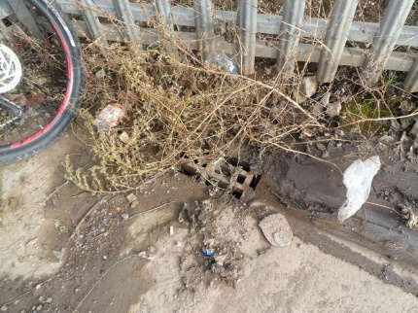
Summer 2016

Feb 2017

4. Footpath 20 Union path
The obstruction to this path will remain an issue, although the situation is now better than it was. Although much of the vegetation has been cut back and there is now more room to pass, the fence is still leaning, but possibly less than before.
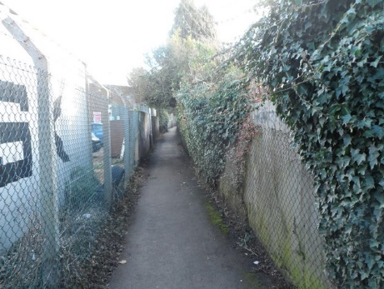
Leaning fence, Union path

5. Gypsy Lane RBW 94
The resurfacing and drainage work carried out last year has been effective. Although I mentioned the possibility of abuse by 4WDs and trail bikes in the last 2 reports, any damage is, I believe, due to legitimate use by contractors’ vehicles. There are a number of relatively shallow potholes on the western side of the path at present, which I will continue to monitor as, if they become as deep as those on RB3, they will be an issue for unsuspecting cyclists and horse-riders. The width of the path is such that these puddles are easily avoided at present.
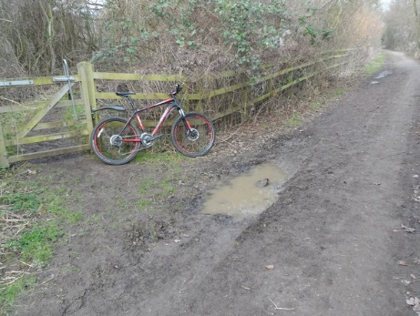
Shallow puddles on RBW 94

6. RB3 Oughtonhead Lane

The S side of the track has recently been resurfaced again between BW5 and FP2. The surface is much more resistant to damage from heavy vehicles, and the track is flat across its entire width at the time of writing (picture below). I see no recent evidence of the use of the path by trail bikes, although, as I have observed before, this is more of a problem in summer. There are sometimes tracks which could be made by trail bikes, but also the new generation of ‘fatboy’ mountain bikes with 4inch wheels leave similar patterns.

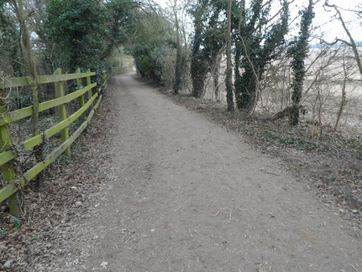
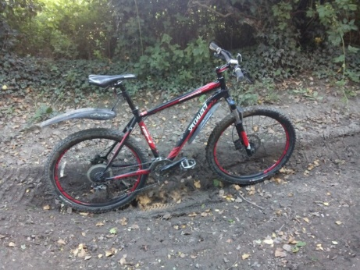
One of a number of potholes on RB3 in
Restored surface Feb 2017. The approximate position of the pothole shown in the other picture is indicated by the arrow. The surface has remained in good condition throughout February.
summer 2016. The surface was level with
the wheel hubs.

7. FP63 Taylor’s Hill

In Taylor’s Hill, damage to the lower layers of brickwork in the wall does not seem to have deteriorated much since it was inspected in summer 2016.

8. FP119 tree root damage
I suggested previously that no action was required on this path. There is tree root damage to the short tarmac section, but the unevenness is not incompatible with the unsurfaced nature of the remainder of the path.

10. Failed lights in Braunds Alley
I believe this has now been addressed.
11. Lack of lights FP14
As noted previously, FP14 has no lighting, although part of it is illuminated when the lights in Wilshere Dacre School are on. I believe it is a focus of antisocial behaviour.
12. Sewage discharge FP70
The situation with regard to sewage discharge into the brook and across the path from the first two access covers starting from Stevenage Rd did not seem to be an issue when I inspected the path, but a resident who lives nearby will continue to report the issue if it arises.

13. Nettle growth
The issues of nettle growth on FP43 and FP55 will continue to be monitored during the summer.

Part C Issues not prioritised in the last report
Narrowing of paths due to crop growth
FP’s 40, 44 and 46 have the potential to be narrowed by crop growth, but this is not currently an issue.

Reference
- Hitchin Town Action Group’s Response to NHDC Submission Local Plan
http://www.hitchinforum.org.uk/wp-content/uploads/2016/11/24.11.16-HTAG-Response-to-SLP-final.pdf

Bill Sellicks 7/3/17

