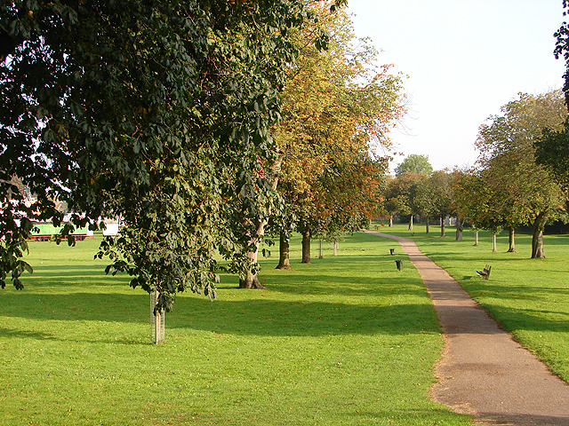

FRIENDS OF BUTTS CLOSE

AN OCCASIONAL NEWSLETTER

October 2013
What a Summer!
Ball games, running toddlers, picnics, pram-pushers, sunbathers and fitness exercisers - Butts Close showed again how valuable it is to all of us. It survived the arid heat, and right now has a thick and green cover, with the autumn leaves falling, and with those rooks strutting around self-importantly, as ever. And it’s been well looked after -

Construction
The work by Borras to extend facilities at the pool and gym has continued. They really do seem to be keeping the site clean and neat, and the pathways have remained in good shape throughout. James Bliss, Manager of the Hitchin Swimming Centre, has said the building works for the new fitness studios and the internal works for the new ‘changing village’ are well on the way. He is working closely with Borras throughout, and there have been no major problems. He is hoping to open the new facilities in early January as planned, subject to any minor delays due to the weather. James also wanted to add his thank you to local residents for their understanding during this period.

Elmside Walk
The reseeded grass verge has taken well, and the new bench seat and bin have been installed – and (miracle!) no ruts have appeared yet from reversing vans. Well done, James and NHDC.
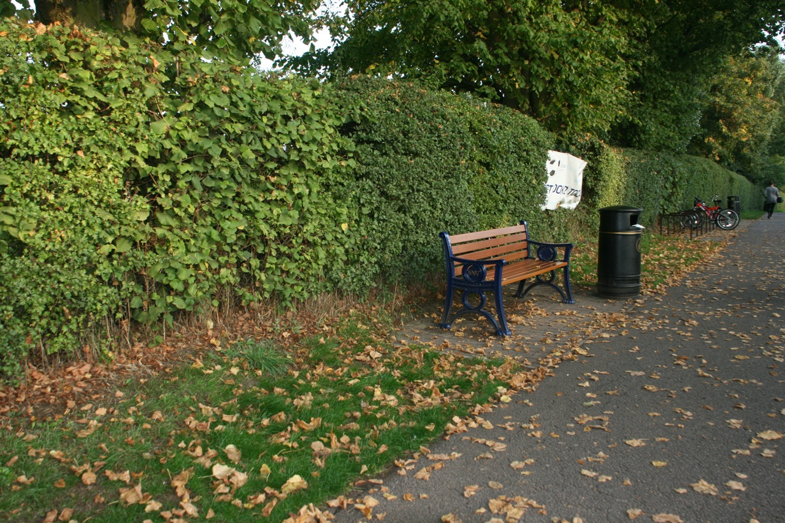

Photo courtesy of Simon Maddison

Needless to say, the graffiti artists have been back on the west-facing wall of the swimming centre – not sure what the tag is, but it’s clearly not Banksy street art.

A Glorious Tree...
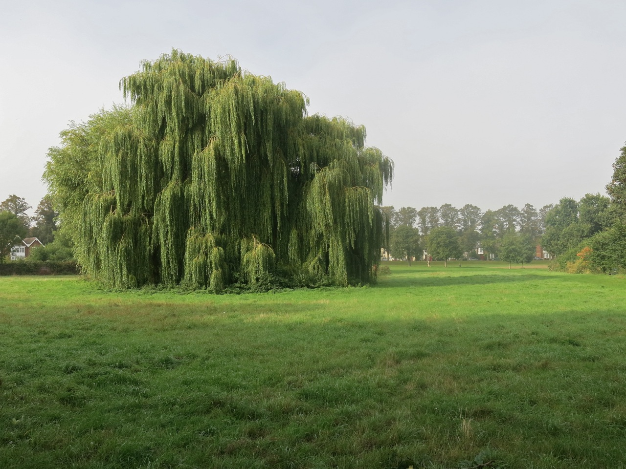
Photo courtesy of Simon Maddison

The beauty of this willow billowing its branches over the pond shows how the work by the Countryside Management Service two years ago has really paid off.

...and what lies Beneath

A great deal of rubbish was collected on the Big Tidy-up Day in May, and the Fire Service cleared the main pond. But at the east edge of the pond there remains some major debris – bins and a metal grid – and the waterside is littered once again with cans and so on. Thomas Ayres of NHDC Grounds Maintenance is on the case. The pond drainage system is being serviced, and the debris will be removed once that is done.
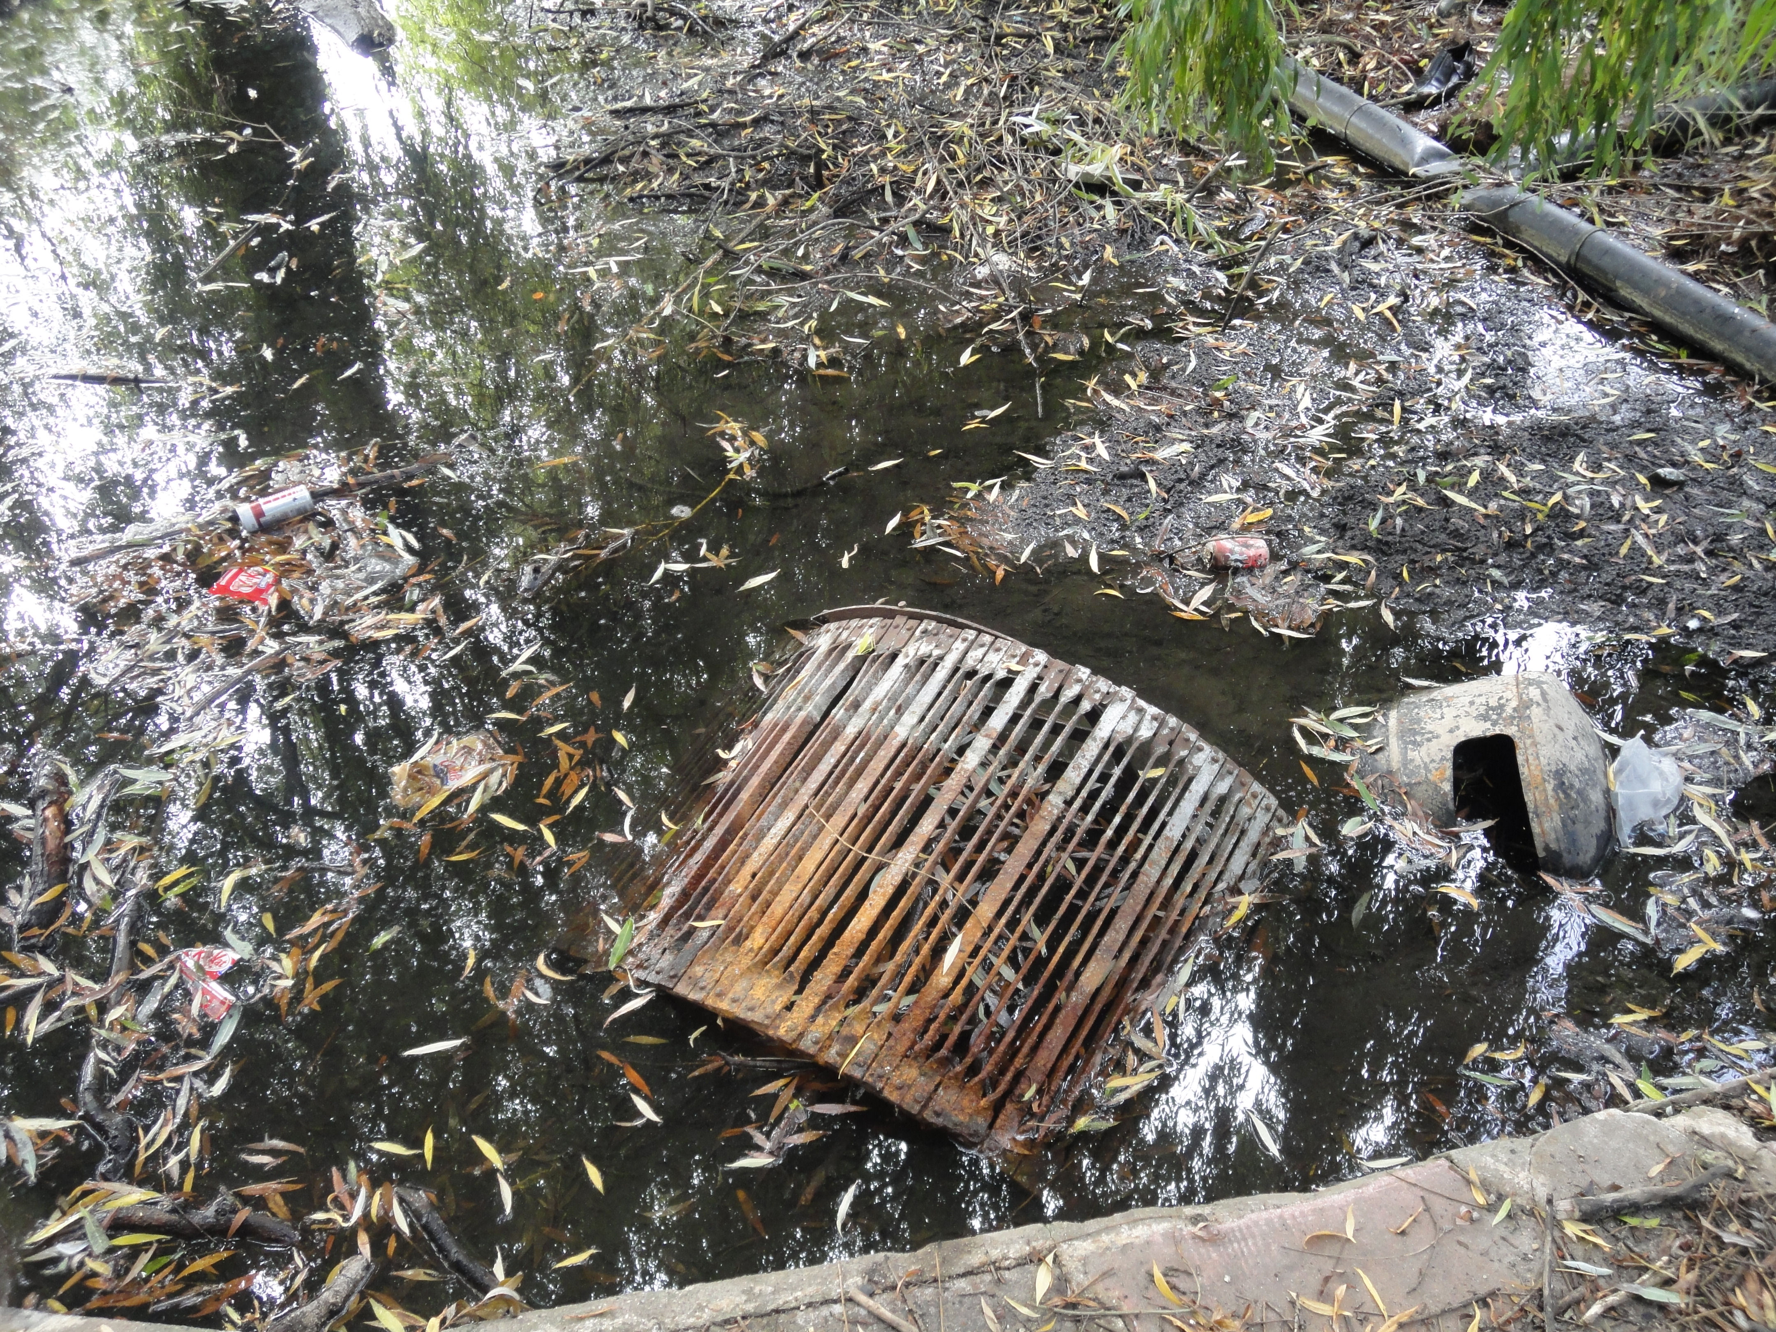

The Tank, and other weapons

As yet no-one has found any more information on the First World War tanks, so we may have to wait until the Hitchin Museum is re-established and their library fully operational, before delving further into this bit of history.

Meanwhile, while most people know that the word ‘Butts’ in Butts Close is connected to archery, you may not know the details. This basically concerned a system of mediaeval National Service.

The longbow was the primary weapon of English and Welsh archers. A monster 6ft in length with a pull of some 120 lbs, proficiency took many years to acquire. A trained archer was expected to shoot 12 to 15 arrows per minute and to hit a target at a minimum of 200 yards. The range of a longbow was about 400 yards and the arrows could pierce armour at ranges of more than 250 yards.

The practise of archery skills was mandated by law as early as 1252, when all Englishmen between the ages of 15 and 60 were ordered to equip themselves with a bow and arrows. A second archery law in 1363 made it obligatory to practise their longbow skills every Sunday and on feast days. This law apparently led to accidents when people were hit by 'loose' arrows, and from 1465 special places were assigned by statute for archery training, usually located on the margins of villages or towns on common land. The targets were typically mounds of earth and the word Butt referred originally to these, but it was later used to describe the whole area of land used for archery.
The training included practising commands and motions which could be carried out automatically in battle: "Ready your bows!" - "Nock!" - "Mark!" -"Draw!" - "Loose!" These cries would have resounded across the battlefields of the Middle Ages.
As the Regiment Fitness exercisers run across Butts Close carrying logs and dragging each other along on ropes, they may not realise that they are in some way continuing a tradition of military-style proficiency dating back over 600 years...

Ellie, Helen, John, Stuart, & Tony for Friends of Butts Close

http://www.middle-ages.org.uk/the-butts.htm
http://en.wikipedia.org/wiki/English_longbow
The nock is the notch where the arrow slots onto the bowstring. To nock is to attach the arrow. See also http://www.sthubertsrangers.org/mediaeval_longbow_technique.htm for detailed techniques!

